**HL Unit 5** **– Abstract Data Structures**  
Quiz 2 – Linked Lists

|  |  |  |  |
| --- | --- | --- | --- |
| **Question 1** | | | |
| Objectives: | 5.1.11 | Exam Reference: | May-17 9 |

Identify the components of a node in a doubly linked list. [3]

|  |  |  |  |
| --- | --- | --- | --- |
| **Question 2** | | | |
| Objectives: | 5.15.6, 5.1.11, 5.1.12, 5.1.13, 5.1.19 | Exam Reference: | Nov-16 11 |

1. The diagram shows a list of names held in a circular linked list. The end of the list is pointed

to by an external pointer, X.

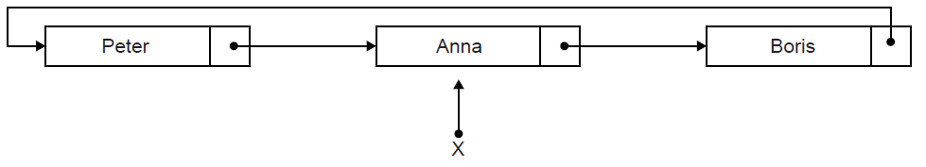

1. State the first name in this circular list. [1]

Two operations are performed on the list in the following order:  
 1. A node containing the name Sarah is inserted at the beginning of the list.  
 2. A node containing the name Ken is inserted at the end of the list.

1. Sketch a diagram showing the resulting circular linked list. [3]

1. Describe how the number of names held in this list could be determined. [4]

1. Explain how a stack could be used to output, in reverse order, all names held

in the linked list. [4]

1. Compare the use of static and dynamic data structures. [3]

|  |  |  |  |
| --- | --- | --- | --- |
| **Question 3** | | | |
| Objectives: | 5.1.12, 5.1.13 | Exam Reference: | Nov-17 13 |

(a) Describe the features of a dynamic data structure. [2]

Consider the following doubly linked list which holds the names of flowers in  
 alphabetical order.



(b) Explain how “Primrose” could be inserted into this doubly linked list. You should   
 draw a labelled diagram in your answer. [6]

Consider the two stacks: FLOWERS and FRUITS.

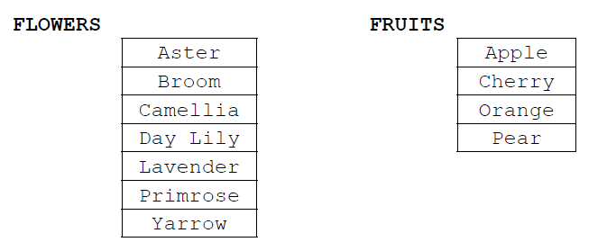

1. 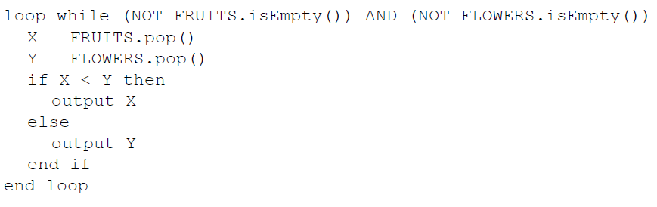Show the output produced by the following algorithm. [4]

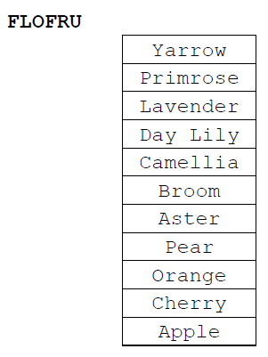  
A third stack, FLOFRU, is needed. It should contain all the data from FLOWERS and FRUITS and will store it as shown below

1. Describe how the FLOFRU stack could be created. [3]